Chapter 11, Solution 5.

Converting the circuit into the frequency domain, we get:
2 Ω
j6
–j2
8∠–40˚

+
−
1 Ω

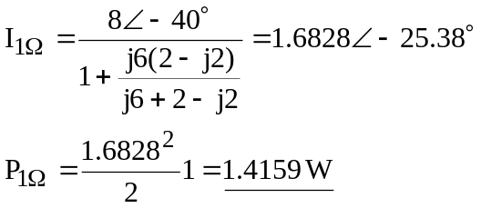

P_{1Ω} = 1.4159 W

P_{3H} = P_{0.25F} = 0 W

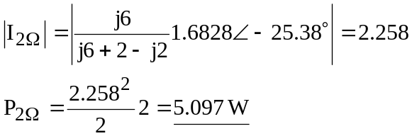

P_{2Ω} = 5.097 W

